(Approx. 519 words)

Linux Mint 12
By Cal Esneault, President, Cajun Clickers Computer Club, LA and leader of many Open Source Workshops & SIGs
February 2012 issue, Cajun Clickers Computer News
http://cccclinuxsig.pbwiki.com
www.clickers.org
ccnewsletter (at) cox.net

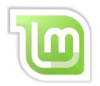
Linux Mint, a community-based operating system (OS) for PC’s, is among the four most popular OS types for average users (Windows, Mac OS, Ubuntu, Mint). Although Mint is a derivative of Ubuntu, it has recently passed its parent in popularity. Known for working “out of the box”, it appeals to those who don’t want to have to “tinker” with their installation. Using a customized software manager, over 30,000 Debian-based software programs are available at no cost.

Recently, the base GNOME development platform was upgraded to GNOME 3, and a new interface was launched that is more adaptable to touch screens and mobile devices (GNOME 3 Shell). Due to superior component and network integration, many distro’s have switched to GNOME 3. Canonical moved to GNOME 3 for Ubuntu, but it chose its own Unity desktop interface in order to support future commercial development plans.
To maintain its non-commercial focus and open software alignment, Linux Mint 12 elected to go with GNOME 3 and GNOME 3 Shell.

The GNOME 3 Shell interface has caused a lot of resistance from long-time GNOME 2 users. Linux Mint 12 has a hybrid desktop strategy by adding features similar to GNOME 2 while still using GNOME 3 Shell as the underlying desktop (see screenshot below).

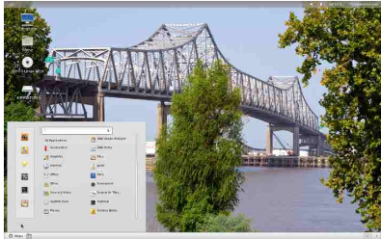

Bottom-left you see the traditional start-button “kicker” screen to launch applications and a bottom panel with buttons for switching virtual workspaces (these have been removed from Unity and standard GNOME 3 Shell). This gives comforting familiarity to existing
users as they transition into the new desk-top metaphor.

By moving the cursor into the top-left corner, you get the GNOME 3 Shell side-screen launcher panel with top buttons to activate the new software “lenses” for alternate selection of applications or files (see below).

With multiple windows open, you can switch applications by many methods: the launcher panel icons, right-side thumbnail icons, the Alt-Tab hot keys, the Superkey-W combo, or the virtual workspace icons on the bottom panel. Choose whichever you want as they are all available!

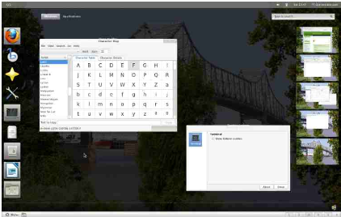

Linux Mint 12 also has available a developmental windows manager called “MATE” which has a more GNOME 2 feel and which allows you to incrementally select which GNOME 3 shell features you want.

The main Linux Mint download is 1.0 GB in size, so you will have to use a DVD or USB for it. An optional CD version is available. My experience is that you need at least 1 GB of memory for it to work. Also, you can choose a “classic” GNOME version at login for older PC’s graphic cards. Expect intense future development since many concepts for this version are quite new.

As Canonical directs desktop Ubuntu to more business users with switch to a 5-year long-term support version so as to focus on tablets and mobile devices in 2014, you may want to visit linuxmint.com to investigate this powerful and popular Linux distro for average users.

